Experimental Evaluation of BeadLoom Game:
How Adding Game Elements to an Educational Tool Encourages Learning Computational Thinking Skills
Acey Boyce, Shaun Pickford, Dustin Culler, Antoine Campbell, and Tiffany Barnes
Department of Computer Science
University of North Carolina at Charlotte
9201 University City Blvd., Charlotte, NC, USA
1-704-687-8577
Tiffany.Barnes@uncc.edu

ABSTRACT

Permission to make digital or hard copies of all or part of this work for personal or classroom use is granted without fee provided that copies are not made or distributed for profit or commercial advantage and that copies bear this notice and the full citation on the first page. To copy otherwise, or republish, to post on servers or to redistribute to lists, requires prior specific permission and/or a fee.
FDG 2010, June 19-21, Monterey, CA, USA
Copyright 2010 ACM 978-1-60558-937-4/10/06…$10.00.
The Virtual Bead Loom (VBL) is a Culturally Situated Design Tool that successfully teaches students middle school math concepts while they learn about and create their own Native American bead artifacts. We developed BeadLoom Game to augment VBL with game elements that encourage players to apply the computational thinking skills of iteration and layering while optimizing the number steps they take to solve a puzzle. In our prior work, we showed that BeadLoom Game is effective at teaching Cartesian coordinates, iteration, and layering. In this study, we use a switching replications experimental design to compare performance of BeadLoom Game with the original Virtual Bead Loom. Our results from two summer camps, one for middle school and one for college-bound high school students, show that BeadLoom Game teaches Cartesian coordinates as well as the VBL but also teaches the computational thinking practices of iteration and layering while the VBL alone does not.
Categories and Subject Descriptors
K.3.2 [Computers and education]: Computer and information science education. – computer science education.
General Terms
Design, Human Factors
Keywords
Game development, education, motivation, evaluation.
1. INTRODUCTION AND RELATED WORK
Culturally Situated Design Tools (CSDTs) [rpi.edu] are a set of educational tools developed to teach students math and computer science through the creation of virtual cultural artifacts. Previous research has shown CSDTs to be effective at both motivating students to use the basic functions of the tools and at teaching the basic mathematic principles associated with those functions [Eglash et al. 2006]. One such CSDT is the Virtual Bead Loom (VBL) which is designed to teach students Cartesian coordinates, symmetry, and geometry through the creation of Native American bead art in a free-play environment. The ease of use and visually appealing cultural artifacts created make it one of the most popular and successful CSDTs [Bert et el. 2009]. The VBL has been shown to produce positive results when teaching basic mathematical principles and students reported increased enjoyment from tool use when compared to traditional assignments [Eglash et al. 2006]. However, as the VBL was used in extensive outreach [Doran et al., 2010], it was found that students often avoided using the more complicated functions of the VBL. These functions, including creative applications of iteration to make symmetric and aesthetic designs, were designed to reflect the rich cultural practices that Native Americans use to design their bead loom art and to show that algorithmic thinking is a natural part of Native American culture. We were disappointed that middle school students did not use and learn these interesting and intellectually rich concepts from the Virtual Bead Loom tool [Boyce and Barnes, 2010]. Iteration and looping are also important, but difficult to learn computer science concepts. According to a survey of computing educators, iteration and looping are the third most difficult concept for novice computer science students to learn [Dale, 2006] making it even more important to address the fact students were avoiding this subject.

In Spring 2009, we began designing a game to motivate students to learn the computational thinking practices of iteration, layering, and optimization from VBL. We first developed a paper version of the game that was played in conjunction with VBL, and later developed BeadLoom Game [Boyce and Barnes, 2010]. We chose to augment the VBL with game elements because of the inherent motivational properties games posses and their potential for improving educational applications [Barnes et al. 2008; Garris et al. 2002]. We hypothesized that the increased motivation in BeadLoom Game would result in educational software that was both effective at teaching all the mathematical and computational thinking skills available in the VBL and would also be more fun and engaging.

Through a series of two experiments it was shown that BeadLoom Game did teach the advanced concepts of layering and iteration while providing stronger internal motivation and improving the replayability of the game. The first experiment was with a middle school summer camp that focused on CSDTs. Although no quantitative evidence was gathered on learning gains, it did show increased motivation to use the advanced functions. In the second experiment with a high school summer camp, students showed statistically significant learning increases from pre to post test in the areas of iteration and layering after playing the game [Boyce and Barnes, 2010]. However, these studies did not directly compare the learning gains of the VBL tool to that of BeadLoom Game. In addition, these studies did not test the ability of BeadLoom Game to teach middle school students math or computational thinking skills. Here, we report on two studies to compare BeadLoom Game and the VBL for enjoyment and learning math and computational thinking practices within a middle school and a high school summer camp.
3. SOFTWARE DESIGN
3.1 Original Virtual Bead Loom
Virtual Bead Loom is a Flash-based free-play tool that allows users to create their own Native American bead art by placing colored beads on a 41 by 41 Cartesian grid. To place the beads, users can choose from six different functions: Point, Line, Rectangle, Triangle, Linear Iteration, and Triangle Iteration. The Point function takes one point (e.g. x and y coordinates) as input and places a single bead at the specified location. This is the simplest function in the Virtual Bead Loom and also the least efficient for creating a full screen design. Students can and sometimes do create full screen designs using only the Point function, but this takes 1681 calls to completely fill the grid.
While it might seem unusual to talk about efficiency in creating art, it is important for several reasons. The VBL is often used in middle school classes and community organizations where time for each activity may be limited to 30 or perhaps 90 minutes. When students spend all of that time making a single design, they reinforce the learning for plotting Cartesian coordinates, an important middle school skill, but they do not learn the more interesting functions that could teach them about properties of lines, triangles, and rectangles, that could help them in developing geometry skills. Students also rarely understand or appreciate the unique algorithmic thinking that Native Americans applied in their hand-made craft of designing bead patterns to be symmetric and aesthetically pleasing.

If students instead learn to use all the rich functions provided by the VBL, they will increase efficiency, allowing more time to explore each tool and learn a variety of skills. The advanced functions place multiple beads each time they are called. For example, the Line and Rectangle functions each take two points as their input parameters and create a line or rectangle of beads based on these points. The Line function places beads along the two points given, while the Rectangle function fills in a rectangular region between the two specified points. These simple function calls can be used to illustrate that two points are enough to specify a line, and two points and a plane are enough to specify a rectangle. Similarly, the Triangle function takes three points for input, and uses them to create a triangle of beads. Although the Line, Rectangle and Triangle functions are slightly more complex, students tend to learn and use them quickly.

The Iteration functions are more advanced, and enable users to produce more complex patterns with a single call. As the name suggests, the Iteration functions use iteration to place beads in complex patterns onto the grid. These functions were not created randomly, but were designed to reflect how Native Americans achieve designs that demonstrate symmetry and aesthetically pleasing color changes in their art. Symmetry is an extremely important element of Native American bead art, reflecting balance and harmony. To make symmetric patterns, Native American bead artists developed algorithms to make diagonal lines and isosceles triangles. Since bead art is constructed one row at a time, these algorithms are based on creating a pattern in one row, and repeating and modifying it in subsequent rows.

The Linear Iteration function shown on the left in Figure 1 illustrates how wing-like patterns are achieved row by row. This function begins with a straight line of beads of a given length (A) at a given point (B). In the next row in the specified direction (+x, -x, +y, or –y), the row is repeated in a graduated color, but may be shifted by adding or subtracting a given number of beads from each side of the line (C and D). This process is repeated, or iterated, for the given number of lines total (E). Using this function introduces students to a function much more complex than simply repeating a given process – this iterative algorithm repeats a process and modifies it at the same time!

The Triangle Iteration function shown on the right in Figure 1 demonstrates how isosceles triangles are made in bead art. A triangle begins with a single bead at a given point (F). Then, for G rows, the Triangle Iteration function copies the previous row. Once that is done, the function adds H beads to each side and copies the row G times. It does this for a given number of rows (I) and in a given direction. Writing a program to do this function is quite complex, requiring a nested loop. Students using this tool have a unique graphical demonstration of nested loops, a notoriously difficult concept for beginning programmers to understand. Although the students do not necessarily see use of this tool as a nested loop, we believe that it introduces nested loops in a fun and interesting way and can form the foundation of understanding and appreciating the computational thinking practice of using nested loops to create repeated patterns.
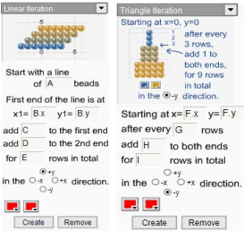
Figure 1: Linear and Triangle Iteration in the Virtual Bead Loom
All functions of the Virtual Bead Loom use layering: if you place one bead on top of another you will only see the top bead and no blending will occur. This is a simple implementation of the Painter’s Algorithm, a key concept in three dimensional computer graphics. When rendering a scene using the Painters Algorithm, the object farthest away from the screen on the Z-axis is drawn first, and closer objects are drawn in descending distance to avoid calculating which objects occlude one another. The same technique can be applied to efficiently “paint” a pattern in VBL. For example, it is common in Native American bead art to build a pattern surrounded by a field of white beads. In the VBL, this is most effectively and efficiently achieved by first drawing a white rectangle before beginning to create other patterns. By thinking computationally and spatially, VBL users can make a pattern efficiently by imagining how different shapes can be layered to draw a desired pattern. Using layering is a powerful computational tool in many types of computer graphics applications – not just rendering but also in tools such as Adobe Photoshop® that use layers to achieve particular artistic effects.

Although the VBL provides these rich functions that allow opportunities to learn more about the Native American culture while also learning algorithms, iteration, and even layering, they are complex and students avoided them. Even when it would be much easier and faster to use an iterative function, students would add beads with the simpler Line and Point functions. There was simply no internal motivation to use these functions.
3.2 BeadLoom Game
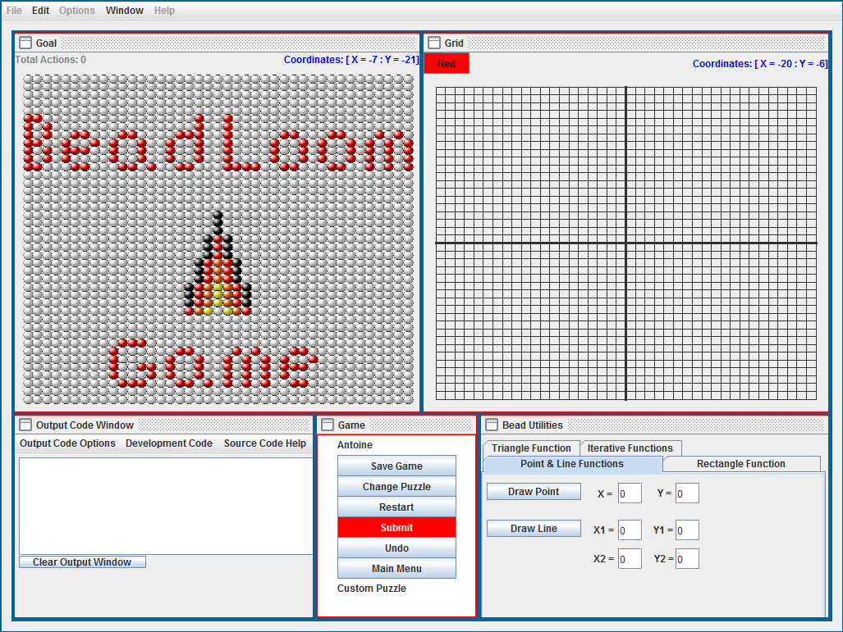
Figure 2: BeadLoom Game, with a target pattern on the left

In order to provide internal motivation to use the advanced functions of VBL, we created BeadLoom Game. The main goal of BeadLoom Game is to create a goal image using as minimal number of function calls, or “moves”. Each time a player uses one of the six bead-placing functions it is considered one move. Whenever a player completes a puzzle they are awarded a medal based on their performance. Players can earn a platinum medal by finding the lowest number of moves needed to complete the puzzle, or the “ideal solution.” Gold medals are awarded for solutions completed it in up to 1.5 times the ideal solution, and silver for up to 2 times the ideal solution. Players earn a bronze medal for completing the puzzle in any number of moves more than twice the ideal solution. BeadLoom Game puzzles encourage players to minimize the number of moves they make, reinforcing an important computational thinking practice of optimization. These puzzles were carefully designed to encourage players to achieve our learning objectives for the computational thinking practices of iteration and layering.

Players can earn bronze medals simply by using the Point function, but puzzles are designed so they must learn and master the skills of iteration and layering to earn platinum medals. The medal system also encourages players to replay completed puzzles to find better solutions. This is especially effective in encouraging competitive game play on the more advanced puzzles, where no one in a group has yet found the ideal solution.

Prior experiments have successfully proven that BeadLoom Game, through the game elements of player objectives, a medal system, and a competitive aspect, can impact student learning of the computational thinking skills of iteration and layering [Boyce and Barnes, 2010]. However, this study did not show if it did so better than the original tool or even if it worked with the original target audience: middle school students.
4. EXPERIMENTAL METHODS
We use a switching replications experimental design that compares the Tool with the Game first in a controlled study, then switches the control and experimental groups to test for ordering effects. This design is particularly effective for educational interventions, because it makes a beneficial intervention available to all students while holding the learning time constant for both groups. It also allows researchers to determine if the intervention has a long-term effect. Eagle and Barnes used this “crossover” experimental design to for compare an educational game for teaching loops to a traditional programming assignment and found that their game was more effective than the program, and also caused long-term learning effects [2009].

We conducted experiments during two 5-day summer camps in 2010. The first camp, Exploring Technology through Culture and Art, engaged 21 middle school students (6 female) to create their own cultural artifacts while learning math and computing. The second camp, Aspire IT, engaged 20 college-bound high school students (7 female) to create games and explore computer forensics. The first day of each camp, students completed a 12-question pretest with 4 questions for each topic: Cartesian coordinates, iteration, and layering. We did not test for the computational thinking practice of optimization. For Cartesian coordinate questions, students plot given points on a graph. Figure 3 shows an iteration question where students fill in the missing numbers in an iterative function. Students also find the number of beads present after a given number of iterations in such a function. For layering questions students find the minimal number of shapes that can be layered to make a given image.
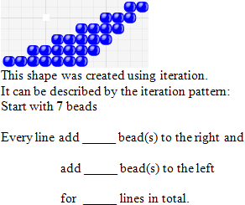
Figure 3: An example iteration question
Each camp was divided into two groups: the Game group played BeadLoom Game first and the Tool group used the original Virtual Bead Loom Tool first. Both groups were walked through a short demonstration of each of the six functions and then given 90 minutes to play BeadLoom Game or use the VBL Tool depending on their group. Afterwards, they were given an isomorphic mid test to evaluate their learning gains.

After using the Game and the Tool respectively, each group was switched to the opposite software. The students were instructed to use the new software for another 90 minutes. The remainder of the camps activities did not focus solely on the use of BeadLoom Game or Virtual BeadLoom. The middle school camp was introduced to other Culturally Situated Design Tools (CSDTs), while the high school camp learned how to use Game Maker game development software [yoyogames.com]. Since none of the other CSDTs or Game Maker use iteration or layering, BeadLoom Game would be the only source of learning in these areas. Each day started off with a 30-minute BeadLoom Game Challenge where students competed to complete a given puzzle in the fewest number of moves. At the end of each day, students were given 30-60 minutes where they could choose from a selection of activities including BeadLoom Game, Virtual Bead Loom, and other tools. During this time students were able to more freely explore all areas of BeadLoom Game, including the custom puzzle creator. Once some custom puzzles were created other students began attempting to find ideal solutions to their peers’ work.

At the end of each camp, students took an isomorphic post test to evaluate overall learning gains, and a short survey to determine how they felt about BeadLoom Game, what features they enjoyed most, and if they preferred BeadLoom Game or Virtual Bead Loom.
5. RESULTS
5.1 Middle School Camp
For the middle school camp, we found that the game and the tool were equally effective at teaching Cartesian coordinates. This is not surprising, as BeadLoom Game and Virtual Bead Loom use the same basic functionality to plot Cartesian coordinates. The success of VBL for teaching Cartesian coordinates is one of its strongest features, so we made sure BeadLoom Game used the same interface.
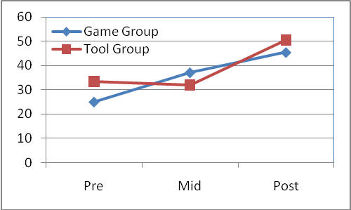
Figure 4: Middle school test results comparing Game & Tool groups
Figure 4 shows the middle school students’ pre, mid, and post test scores on the remaining questions on iteration and layering. As the figure illustrates, the Game group showed increases in knowledge during the first session and continued to learn through the remainder of the summer camp. The Tool group showed no learning until after they began playing the game. Table 1 compares the learning differences for each group on these questions. There was a significant difference in the learning gains from pre to mid test, indicating that the Game group learned more from 90 minutes playing the Game than the Tool group learned from the same amount of time using Virtual Bead Loom. Since the Tool group accomplished the same overall learning gains as the Game group from pre to post, we believe that most of the learning gains for the week can be attributed to BeadLoom Game.
Table 1: Learning differences between middle school groups
 | N | Mid-Pre | Post-Mid | Post-Pre
Game | 11 | 12.12 | 8.33 | 20.45
Tool | 10 | -1.67 | 18.75 | 17.08
Difference p value |  | 0.019 | 0.27 | 0.70
t-stat |  | 2.57 | -1.12 | 0.38

During the week, the middle school students were introduced to one to two additional CSDTs every day through Wednesday. At the end of each of these days, students were given free time where they could work with any of the CSDTs. As Table 2 shows, BeadLoom Game was the most popular selection every day.
Table 2: Free time CSDT selection by day
 | Monday | Tuesday | Wednesday
BeadLoom Game | 16 | 19 | 13
Virtual Bead Loom | 5 | 0 | 0
Other CSDTs | - | 2 | 8

When asked about their enjoyment of the game, the middle schools students gave BeadLoom Game an average rating of 3.88 out of 5. When asked which they preferred, 16 selected BeadLoom Game and 5 chose Virtual Bead Loom. One student explained that he like BeadLoom Game best “because we have to solve [puzzles] using our brains.” When asked to rank the CSDTs in order of preference, students ranked Virtual Bead Loom fourth most popular while BeadLoom Game was ranked second. Over the course of the 5-day summer camp middle school students earned 183 platinum medals.
5.2 High School Camp
Similar to the middle school camp, there were no statistically significant differences between the high school Tool and Game groups for learning in Cartesian coordinates. These advanced high school students already had a strong working knowledge of Cartesian coordinates and showed very little change from pre to mid and on to post in either group. Figure 5 shows the high school students’ pre, mid, and post test scores on the iteration and layering questions. Like the middle school camp, the Tool group showed no learning gains by the mid test while the Game group saw learning gains from pre to mid test and mid to post test. Once again the Tool group achieved learning gains only after playing the game.
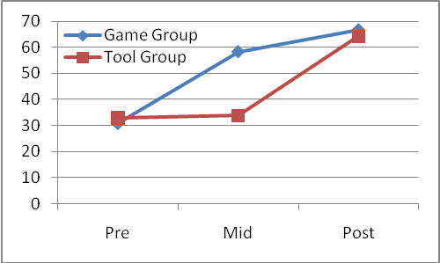
Figure 5: High school test results comparing Game and Tool groups

Table 3 compares the learning differences between the groups for the iteration and layering questions. There was a significant learning difference for the Game group from pre to mid test and for the tool group from mid to post test; in other words, after exposure to BeadLoom Game. Like the middle school Tool group, the high school Tool group was able to overcome the initial learning gains difference and catch up to the game group by playing BeadLoom Game.
Table 3: Learning differences between high school groups

 | N | Mid-Pre | Post-Mid | Post-Pre
Game | 10 | 27.50 | 8.33 | 35.83
Tool | 10 | 0.83 | 30.42 | 31.25
Difference p value |  | .0012 | .0031 | .63
t-stat |  | 2.57 | -1.12 | .49

When asked to rate the game, the high school students gave BeadLoom Game an average rating of 3.5 out of 5. When asked which they preferred, 13 chose BeadLoom Game and 7 chose Virtual Bead Loom. One high school student wrote of BeadLoom Game, “The game forces me to use more complicated iterations to improve my score which makes it a fun activity and a good learning tool.” During their 5-day camp the high school students earned 215 Platinum medals.

It is interesting to note that the middle school Game group outperformed the high school Tool group on the mid test. The middle school Game group averaged a 37.12% on iteration and layering while the high school Tool group averaged a 31.67%. Although it was not by a statistically significant margin, we were still surprised that the middle school students outperformed the college bound high school group after playing BeadLoom Game.
6. DISCUSSION
The results of these two experiments show that BeadLoom Game is more effective than the Virtual Bead Loom at teaching the advanced concepts of iteration and layering to both middle and high school students. Anecdotally, we observed that the Virtual Bead Loom and BeadLoom Game complemented one another, as the original CSDT provides an easier environment to learn the basic concepts and experiment with the more advanced functions while the game motivates students to build stronger iteration and layering skills.

In our previous work, we showed that BeadLoom Game could teach high school students the same concepts as the Virtual Bead Loom educational tool while being fun and motivating [Boyce and Barnes 2009]. However, that study did not compare BeadLoom Game with the VBL tool. It also lacked quantitative evidence that the tool worked with middle school students, the original target audience of the tool. Our study showed a positive comparison with the Virtual Bead Loom in learning gains for the important computational thinking skills of iteration and layering while teaching Cartesian coordinates just as effectively. We have shown statistically significant learning gains in iteration and layering for all students after exposure to BeadLoom Game.

The distinction between a successful game and one that is more successful than the original educational software it was derived from was an important one to establish. We already knew games have a strong motivating force [Barnes et al. 2008; Garris et al. 2002], but this study shows direct learning gain improvements resulting from the conversion of a successful educational tool into an educational game. We believe that our study shows that the addition of simple objectives and competitive aspects can increase students’ internal motivation and enjoyment while also improving learning outcomes.
7. CONCLUSIONS AND FUTURE WORK
The results of the study showed that BeadLoom game not only taught the intended math and computational thinking concepts, but did so better than the original Virtual Bead Loom. The game showed statistically significant learning differences in groups of middle and high school students who used it when compared to groups who used the tool. By adding game elements we have been able to both increase student motivation and achieve higher learning gains than the tool in as little as 90 minutes. Our results indicate that the incorporation of game elements into educational software can increase motivation and learning gains through fun and challenging game objectives that directly correlate to learning objectives.

In our future work, we plan to further investigate the importance that individual game elements have in converting educational software into games. For example, we plan to use feedback from users who prefer the Virtual Bead Loom to find what features they like best to determine how free play could be integrated into BeadLoom Game. We would also like to expand to an online BeadLoom Game community and then run experiments to determine what effects the community aspects such as leaderboards and custom puzzles have on motivation and learning. If the community aspects are shown to be beneficial then we will integrate other educational games and tools into this online collaborative community.
8. ACKNOWLEDGMENTS
We would like to gratefully acknowledge Dr. Kera Bell-Watkins and her fall 2009 software engineering class for making a Java version of the Virtual Bead Loom upon which we built BeadLoom Game. We would also like to thank Dr. Ron Eglash for his enthusiastic support and original development of the CSDTs. This work was partially supported by the National Science Foundation Grants No. CNS-0634342 Improving Minority Participation in the Computing Pipeline, CNS 0739216 BPC-AE: The STARS Alliance: A Southeastern Partnership for Broadening Participation in Computing (2008-2011) and NSF-CNS 0540523 BPC-A: The STARS Alliance: A Southeastern Partnership for Diverse Participation in Computing (2006-2009), IIS-0757521, Game2Learn: Creative Computing Education, and the UNC Charlotte Diversity in Information Technology Institute.
9. REFERENCES
Barnes, T., E. Powell, A. Chaffin, H. Lipford. Game2Learn: Improving the engagement and motivation of CS1 students. ACM GDCSE 2008.

Bert, C., K. King, A. Brown, D. Watkins. Standardizing Culturally Situated Design Tools. Accessed February 8, 2010. http://www.cra.org/Activities/craw_archive/dmp/awards/2009/Bert/Website/FinalReport.pdf

Boyce, A, and T. Barnes. BeadLoom Game: Using Game Elements to Increase Motivation and Learning. Proc. 5th ACM Intl. Conf. Foundations of Digital Games (FDG 2010). Monterey, CA, USA, June 19-21, 2010.

Dale, N. B. Most difficult topics in CS1: results of an online survey of educators. SIGCSE Bull. 38, 2 (2006), 49-53

Doran, K., A. Boyce, S. Finkelstein, T. Barnes. (2010). Short Paper: Reaching out with Game Design. Proc. 5th ACM Intl. Conf. Foundations of Digital Games (FDG 2010). Monterey, CA, USA, June 19-21, 2010.

Eagle, M., and T. Barnes. Experimental evaluation of an educational game for improved learning in introductory computing. In SIGCSE ’09, PP. 321-325, 2009.

Eglash, R., Bennett, A., O’Donnell, C., Jennings, S., and Cintorino, M. (2006). “Culturally Situated Design Tools: Ethnocomputing from Field Site to Classroom.” American Anthropologist 108(2): 347-362.

Garris, Ahlers, & Driskell. Games, motivation, and learning: a research and practice model. Simulation and Gaming, Vol. 33, No. 4, 2002, 441-467.

RPI.EDU. Culturally Situated Design Tools Accessed: September 9, 2010. http://csdt.rpi.edu

YOYOGAMES.COM Game Maker Accessed: February 9, 2010. http://www.yoyogames.com/

